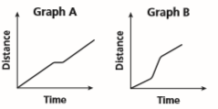
Choose the best graph for the scenario.
1. A person walks leisurely, stops, then continues walking.
___________________
2. A person jogs, then runs, and then jogs again.
___________________
Sketch a graph for each situation.
3. Julie reads 2 books a month for 5 months. 4. A ball is dropped from a second story window and bounces to a stop on the patio below.

5. A girl was walking home at a steady pace. Then she stopped to talk to a friend. After her friend leaves, she jogs the rest of the way home.

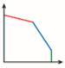
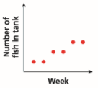
Write a scenario for each graph. (Don’t forget to assign units to #7)
6. 7.

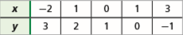
8. b.) Identify domain & range
a.) Express as a mapping diagram.
c.) Explain if it’s a function.

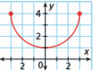
9. a.) Identify domain & range b.) Explain if it’s a function.

Evaluate.
10. $f\left(x\right)= -3x+4 when x=-2$ 11. $g\left(x\right)=2x^{2} when x= -3$

12. Bowling costs $3 per game plus $2.50 for shoe rental. What is the independent and dependent variables? Write a function rule.

13. An engraver charges a $10 fee plus $6 per line of engraving. Write a function rule and find a reasonable domain and range for up to 8 lines of engraving.

Determine whether the sequence is arithmetic. If so, identify the common difference and give the next three numbers.
14. 11, 6, 1, -4,… 15. -4, -3, -1, 2,… 16. 7, 21, 30, 45,…

Find the indicated term in the sequence.
17. 32nd term: 18, 11, 4, -3,… 18. 24th term: a₁ = 4, d = 6

The table shows possible recommendations for the number of hours of sleep that children should get every night.
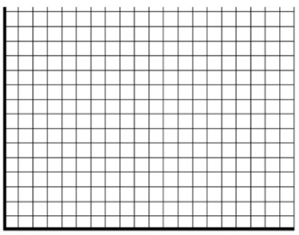
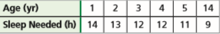

19. Create a scatterplot. Don’t forget labels & a title!
20. Describe the correlation
_____________________________________
21. Predict how many hours of sleep a 16-year-
old should get
_____________________________________
Graph each function with the given domain using a table.
22. $y=-3x+4 D: \left\{-2, -1, 0, 1, 2\right\}$ 23. $y=\left|x-1\right| D: \left\{-3, 0, 1, 3, 5\right\}$

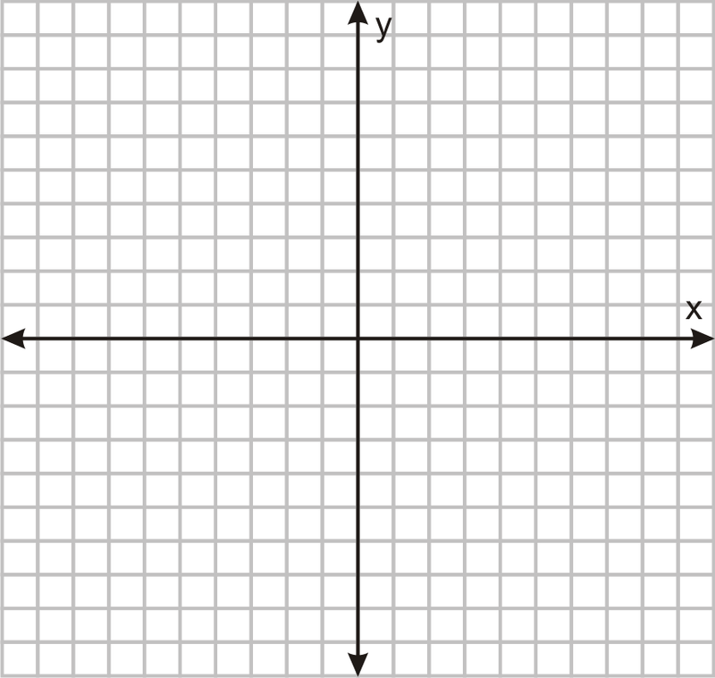

Graph each function using a table.
24. $y=x-5$ 25. $y=x^{2}-5$

