Use the quadratic equation to find VERTEX, AXIS OF SYMMETRY, and Y-INTERCEPT.
1) $y=x^{2}-4x+7$ 2) $y=2x^{2}-4x-1$

3) $y={-2x}^{2}+16x-35$ 4) $y=-x^{2}-6x-10$

SKETCH the following quadratic functions from vertex form. (only need 1 point, like foldable)
5) $f\left(x\right)={-\left(x-3\right)}^{2}+2$ 6) $y= {\left(x+1\right)}^{2}+2$ 7) $h\left(x\right)= ({x-4)}^{2}$

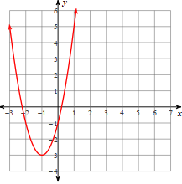
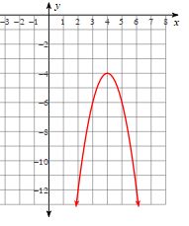
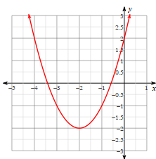
Write the equation that corresponds to the graph in VERTEX FORM.
8) 9) 10)

Convert the standard form equation into VERTEX FORM.
11) $y=x^{2}+2x-1$ 12) $y=x^{2}-4x+3$

13) $y=x^{2}+6x+7$ 14) $y=x^{2}-8x+17$

Use the graphs to identify the ZEROS and the INTERVALS. (Remember: intervals are x-values only!)
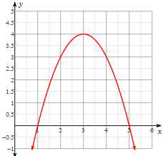
15) Positive & Increasing 16) Negative & Increasing
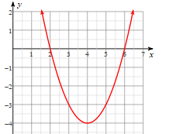
Interval: Interval:

Zeros: Zeros:

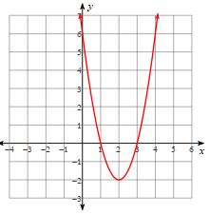
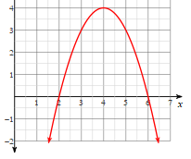
17) Negative & Decreasing 18) Negative & Decreasing

Interval: Interval:

Zeros: Zeros:

