Use the function to identify the quadratic properties AND GRAPH the function.
1) $f\left(x\right)= x^{2}+8x+15$ 2) $f\left(x\right)= -2x^{2}-8x-6$

Vertex: Vertex:
Max or Min at what? ____ Max or Min at what? ____
Axis of Sym: Axis of Sym:
Zeros: Zeros:
Y-Int: Y-Int:
D: R: D: R:
Inc: Dec: Inc: Dec:
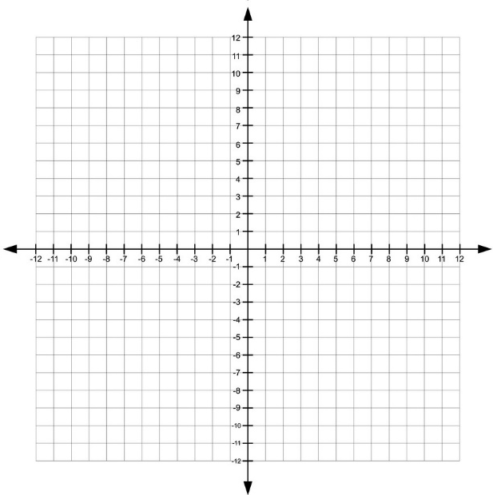
Pos: Neg: Pos: Neg:
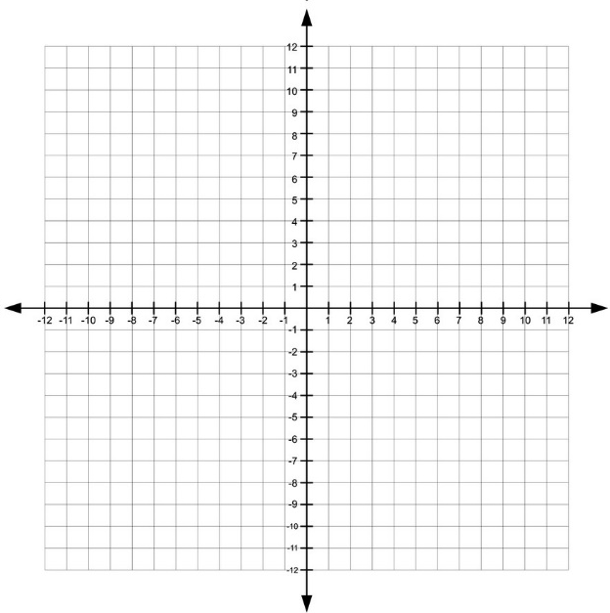

Convert the following standard form problems into vertex form.
3) $y=x^{2}+8x+12$ 4) $f\left(x\right)=x^{2}-2x-6$

5) $y=x^{2}-14x+16$ 6) $f\left(x\right)={2x}^{2}+20x-14$

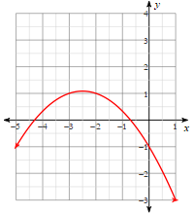
Use the graph to identify the quadratic properties. (estimate numbers as needed)
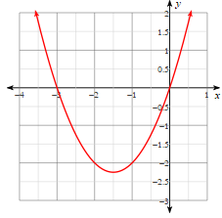
7) 8)

Vertex: Max or Min at what? ____ Vertex: Max or Min at what? ____
Axis of Sym: Y-Int: Axis of Sym: Y-Int:
Zeros: Zeros:
D: R: D: R:
Inc: Dec: Inc: Dec:
Pos: Neg: Pos: Neg:
Graph the following quadratic functions from vertex form.
9) $f\left(x\right)={\left(x+1\right)}^{2}+4$ 10) $g\left(x\right)= -{\left(x-3\right)}^{2}+6$ 11) $h\left(x\right)= -({x-1)}^{2}$

